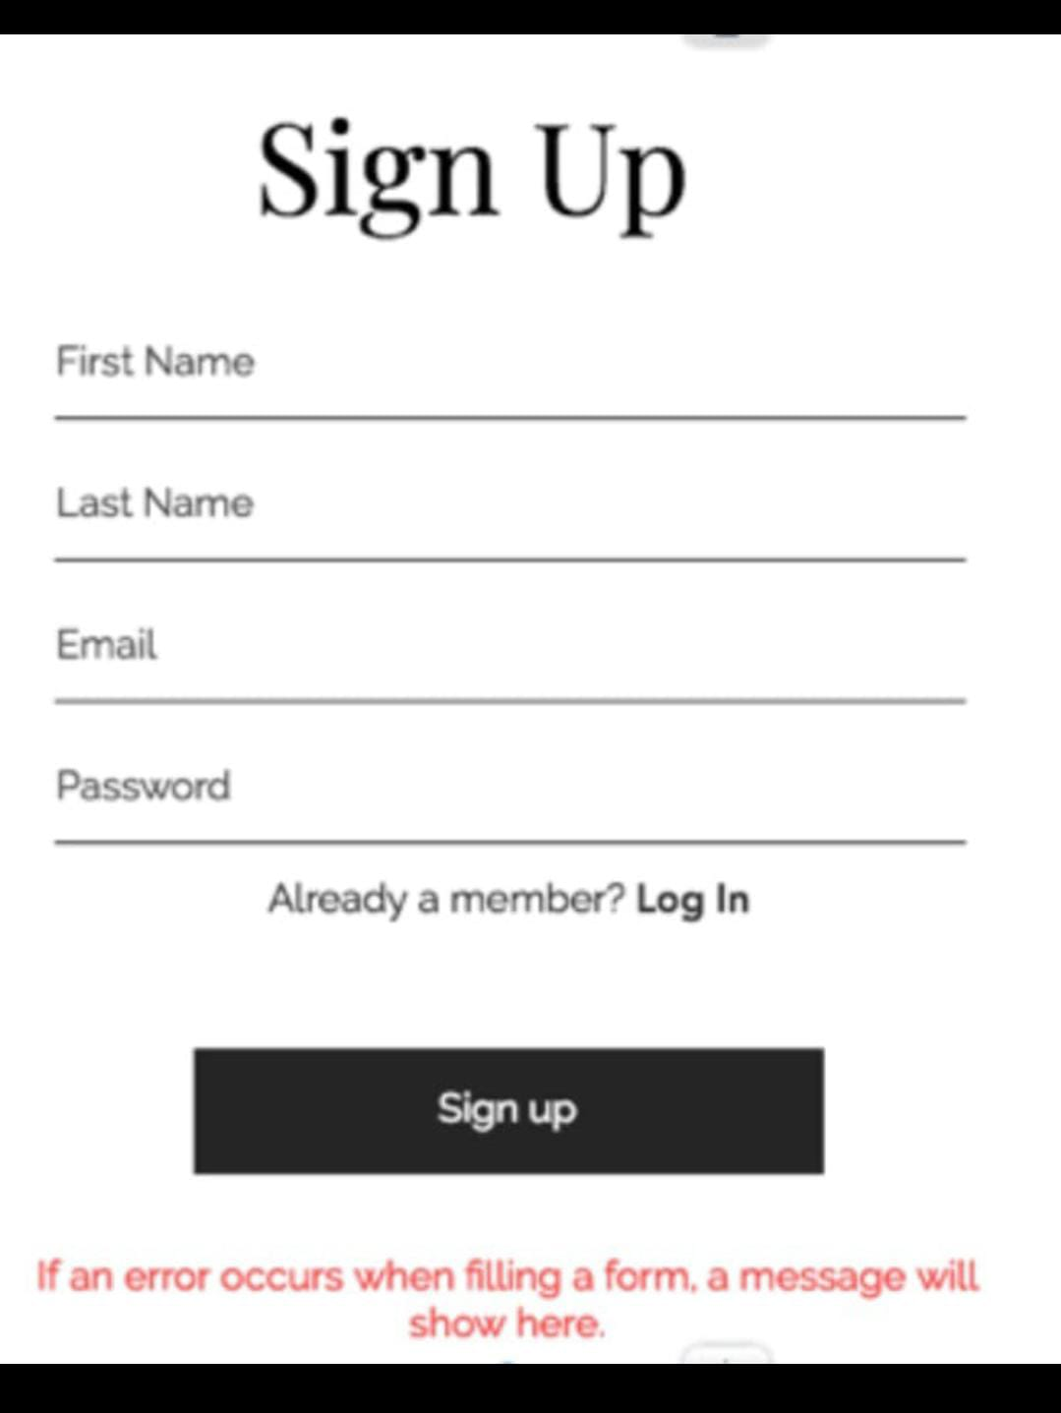

**Test Scenarios for Sign Up Page**

1. Verify the page loads within an acceptable time frame.
2. Verify that all fields should not be blank.
3. Verify the valid first Name , Last Name , email and password.
4. Verify the invalid first Name , Last Name , email and password.
5. Verify the valid first Name , Last Name , and invalid email password.
6. Verify the valid first Name , Last Name , email and invalid password.
7. Verify the valid first Name , Last Name , invalid email and valid password.
8. Verify the invalid first Name , Last Name , and valid email and password.
9. Verify the email should not contain spaces.
10. Verify the password should not contain spaces.
11. Verify the email format is up to the standard conventions (e,g., user@gmail.com).
12. Verify the valid first Name , Last Name should be a minimum of four letters.
13. Verify the valid first Name & Last Name are already registered or not.
14. Verify the valid email is already registered or not.
15. Verify the error message clearly indicates “Email is already registered”.
16. Verify the hyperlink of LogIn is working correctly.
17. Verify the SignUp button is working correctly.
18. Verify the SignUp button successfully register users in the database.
19. Verify the SignUp button register users with just one click.
20. Verify the error should appear at the bottom of the signup button.
21. Verify the asterisk is styled consistently and is clearly visible.
22. Verify the comparison is case-sensitive if required by the system.
23. Verify the error message is clear and specific (e.g., “Invalid email format”).
24. Verify the success message is informative and provides the next steps (e.g., check email for verification).
25. Verify the SignUp form displays a successful message after a successful submission.
26. Verify that the redirection happens correctly and the login page loads as expected.
27. Verify that the user is not able to navigate back to the registration page using the browser's back button after successful registration.